NUERA – Wake Your Mind
AI-Powered Intelligent Cognitive Alarm Platform

Milestone 2 Documentation
Name: Indhu Ravula
Role: Member 3 – AI & Analytics

1. Project Overview
Nuera – Wake Your Mind is an AI-powered Intelligent Cognitive Alarm Platform designed to help users build healthy wake-up habits through cognitive engagement and intelligent analytics. Unlike conventional alarm applications, Nuera requires users to complete cognitive activities before dismissing the alarm, ensuring they are mentally alert after waking up. My contribution focuses on the AI & Analytics module.

2. Objectives
- Calculate Habit Score.
- Predict Difficulty Level.
- Generate Recommendations.
- Track User Progress.
- Calculate Challenge Score.
- Verify User Completion.
- Generate Challenge Analytics..

3. Technologies Used
Python
FastAPI
Swagger UI
VS Code
Git & GitHub

4. AI & Analytics Modules
4.1 analytics.py – Implements the logic for calculating the user's Habit Score.
4.2 difficulty.py – Predicts the challenge difficulty based on the Habit Score.
4.3 recommendation.py – Generates personalized recommendations to improve wakeup habits.
4.4 progress.py – Tracks and displays the user's daily and weekly progress.
4.5 challenge_score.py – Calculates the user's score after completing cognitive challenges.
4.6 verification.py – Verifies whether the user has successfully completed the wake-up challenge.
4.7 challenge_analytics.py – Generates analytical reports on challenge performance.
4.8 main.py – Integrates all modules and exposes them as FastAPI REST APIs.

5. API Endpoints
API Endpoint | Description
/habit-score | Calculates the user's Habit Score.
/difficulty | Predicts the user's challenge difficulty level.
/recommendation | Generates personalized recommendations.
/progress | Displays daily and weekly progress.
/challenge-score | Calculates the cognitive challenge score.
/verification | Verifies successful challenge completion.
/challenge-analytics | Generates challenge performance analytics.

6. Workflow
User
↓
FastAPI APIs
↓
AI & Analytics Processing
↓
Swagger UI Response
Description:
The user sends a request to a FastAPI endpoint, where the AI & Analytics module processes the request and returns the output through Swagger UI.

7. Results
All AI & Analytics APIs were successfully tested using Swagger UI. The implemented modules generated the expected outputs for Habit Score, Difficulty Prediction, Recommendation, Progress Tracking, Challenge Score, Wake-up Verification, and Challenge Analytics, confirming the successful completion of the AI & Analytics module.

8. Screenshots

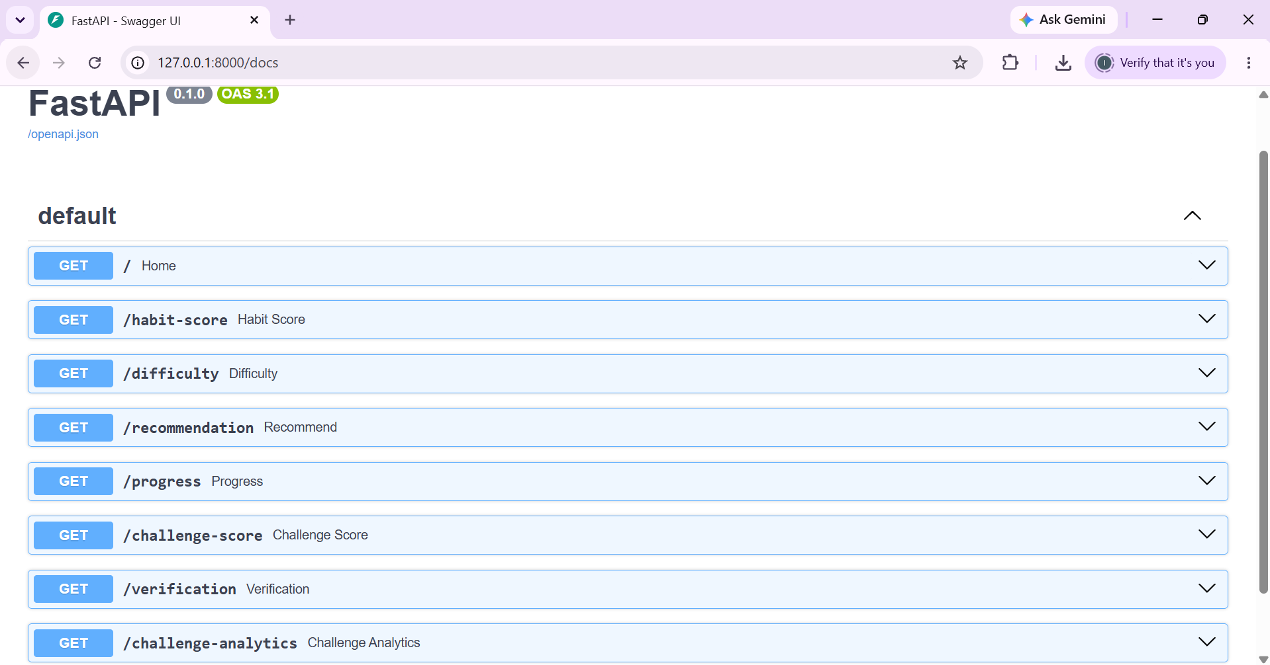
Figure 8.1 Swagger UI

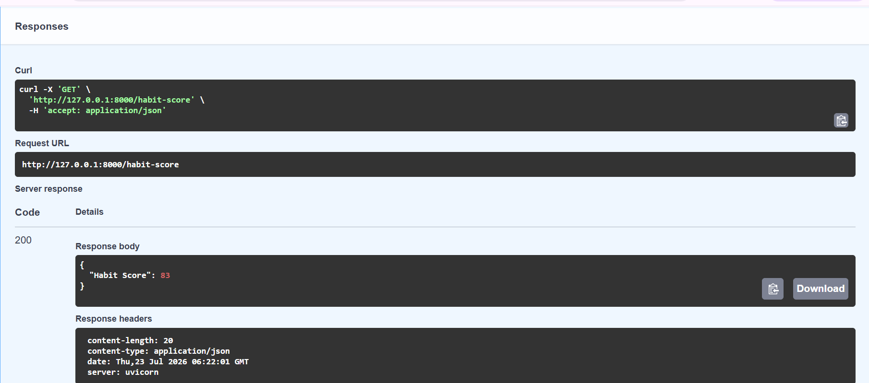
Figure 8.2 Habit Score

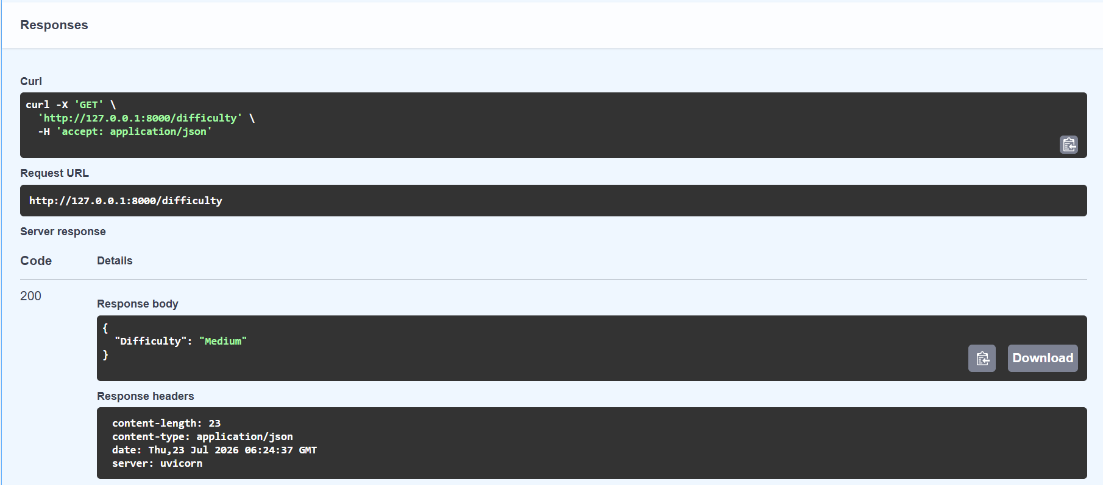
Figure 8.3 Difficulty Prediction

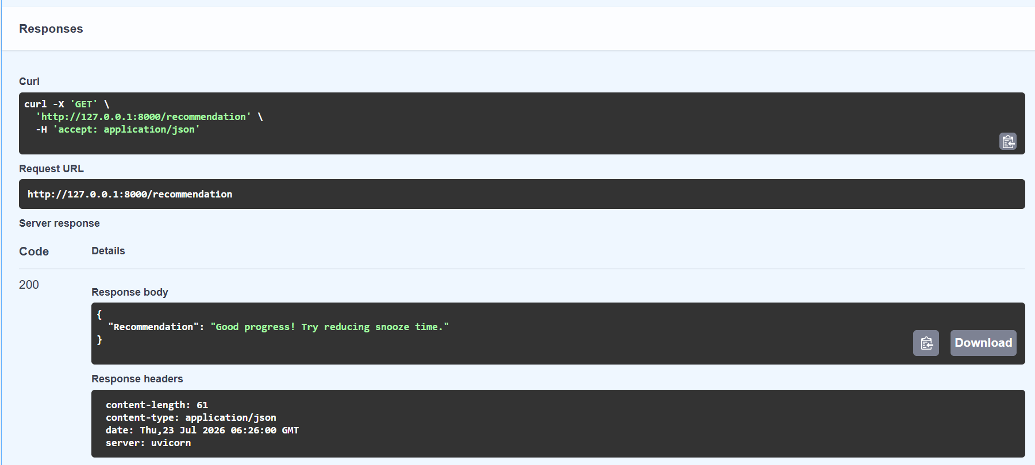
Figure 8.4 Recommendation
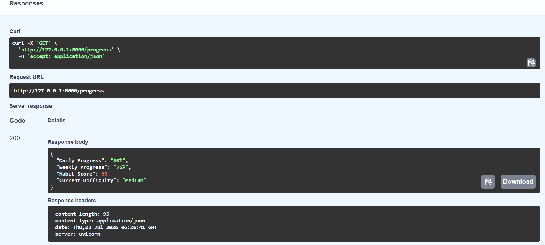
Figure 8.5 Progress

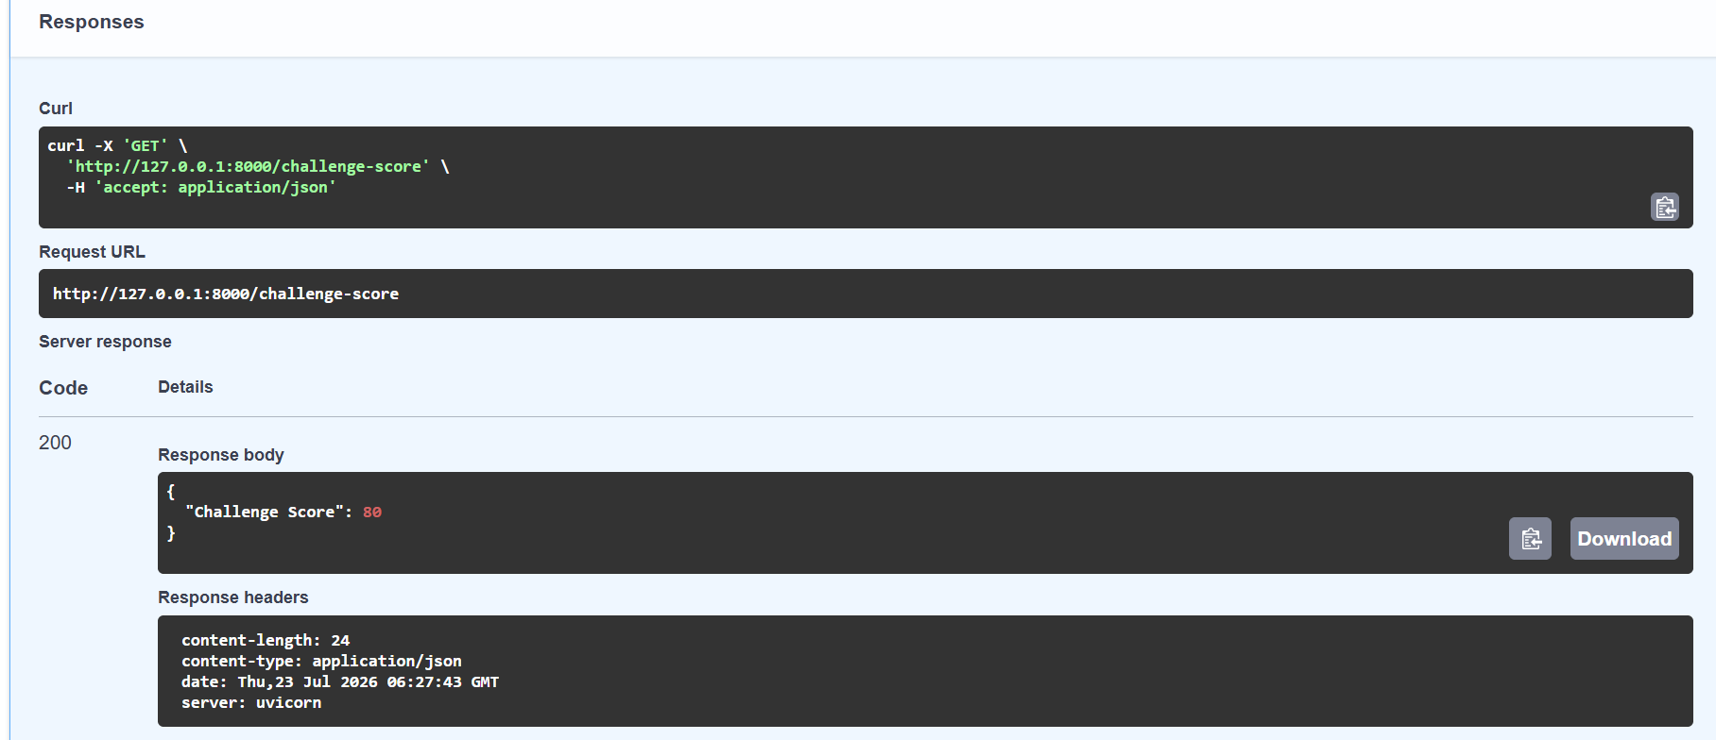
Figure 8.6 Challenge Score

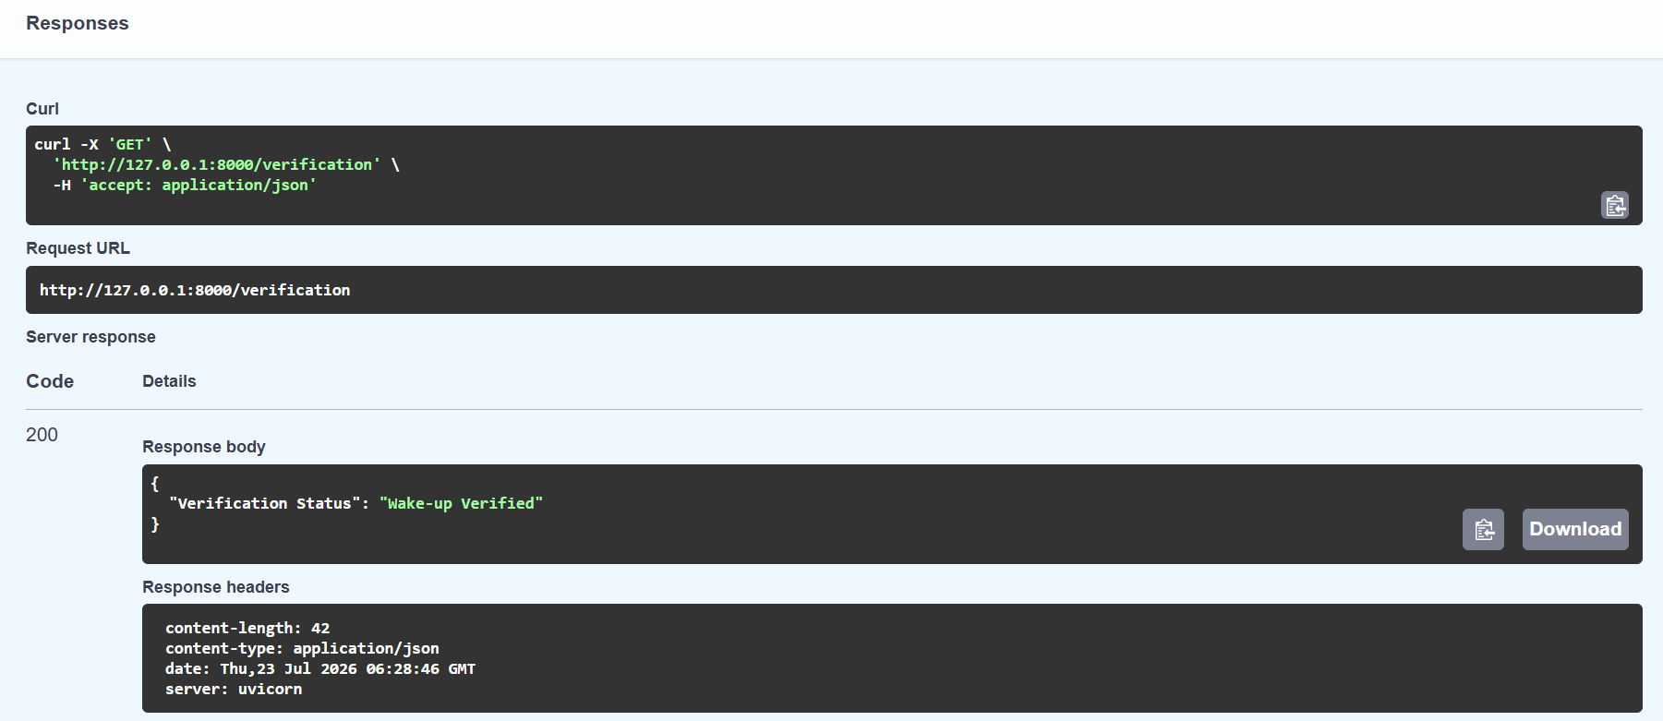
Figure 8.7 Verification

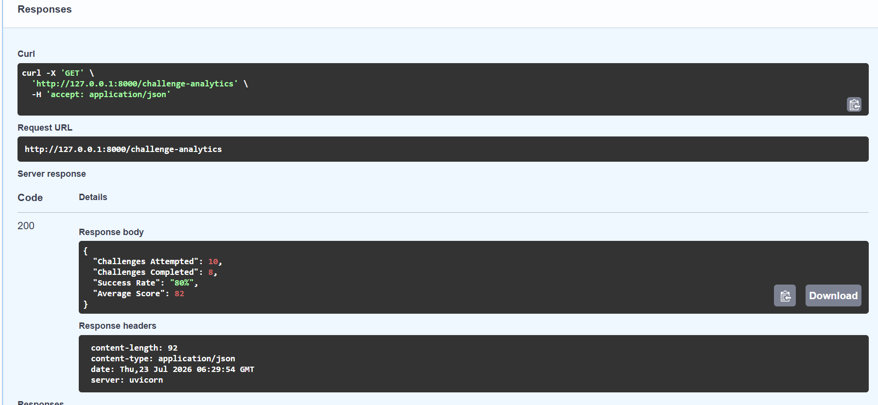
Figure 8.8 Challenge Analytics

9. Future Work
The AI & Analytics module can be further enhanced by integrating it with the team's Cognitive Challenge module, connecting it to a database for persistent user data storage, and integrating it with the frontend to provide a complete user experience. Future enhancements also include adaptive AI-based recommendations and real-time analytics dashboards.

10. Conclusion
The AI & Analytics module for Milestone 2 was successfully implemented. The developed APIs calculate habit score, predict difficulty, generate recommendations, track progress, evaluate challenge performance, verify completion, and provide analytics. The module is ready for integration with the team's cognitive challenge engine.

